Requirements Testing

Group Name: Team Supreme

Project Name: Pagliai’s Inventory Tracking System (P.I.T.S)

Team Members: Dakota Carmichael, Kyle Scott, Jerry Liu, Coleten Mcguire, Sandip Subedi, and Eric Martin

* 1. Requirement: Scan Gun connection to iOS application/Database
  2. Precondition: The input from scanning a label with the scan gun must pull the current quantity and unit of that item and store it in the iOS application’s text fields correctly.

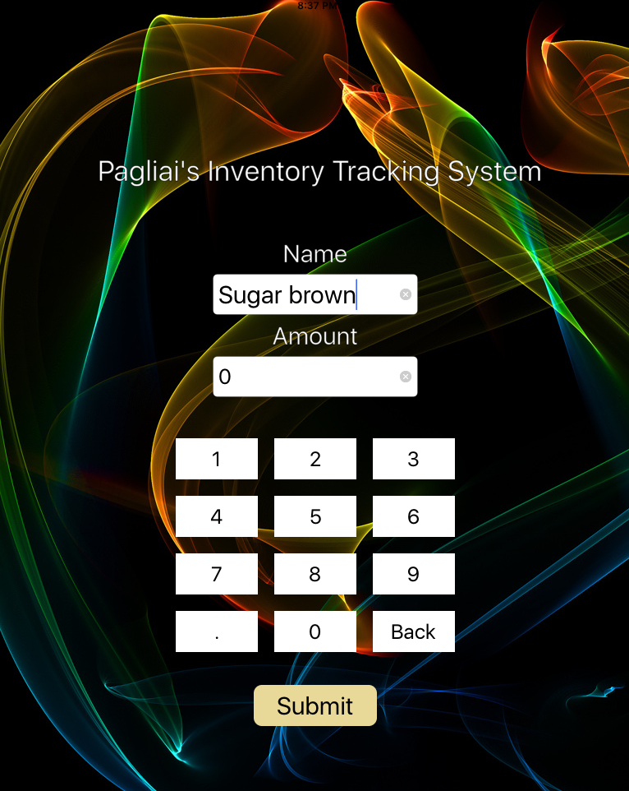

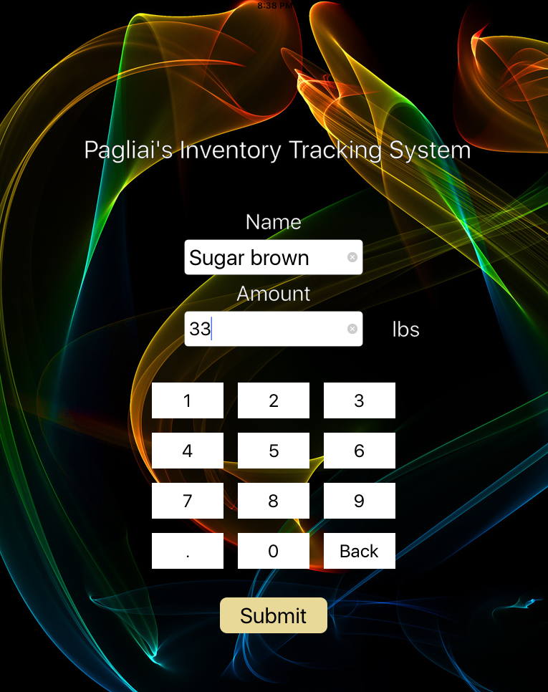

* 1. Postcondition: When the user scans an item that is in the database, it correctly pulls in the current amount (33) and its units (lbs).

1.4 Precondition: When the user submits the item and the new amount, the iOS application should send it to the database.

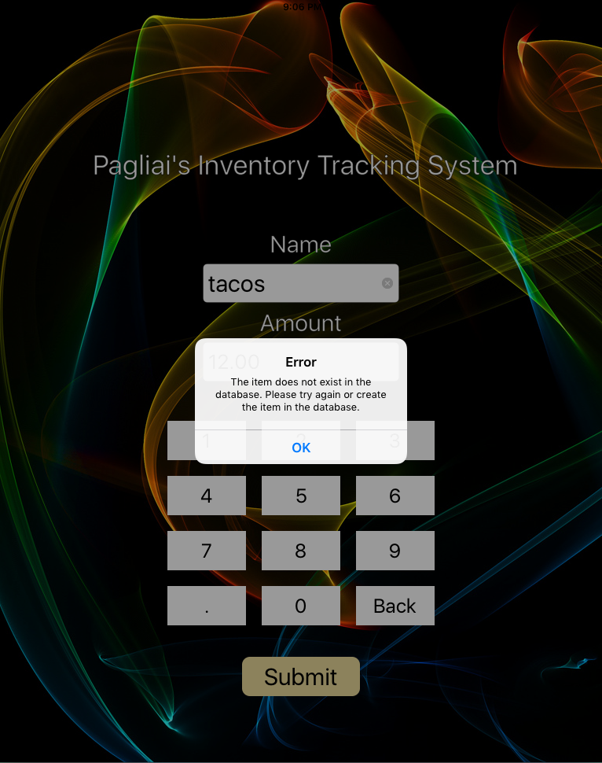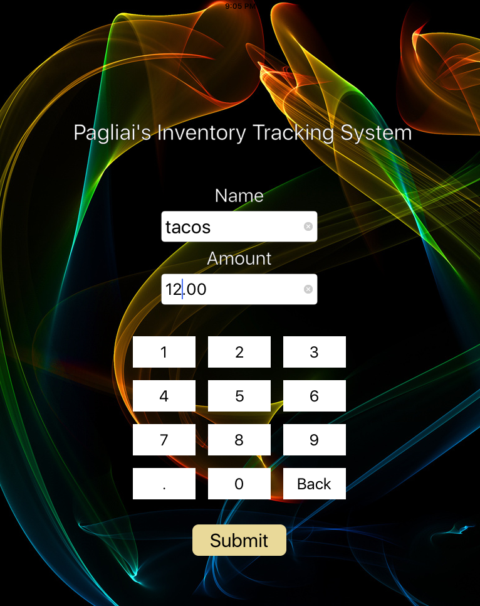

1.5 Postcondition: If the item is not in the database, the iOS application will display an alert notifying the user to enter a valid item.